June 15, 2018

Dear Registrars,

Re: CDRAF Working Group on National Competencies for
General Dentists

The first in-person meeting of the CDRAF Working Group on National Competencies for General Dentists was held on June 7, 2018. Attendees were Dr. Patti Ling, MB; Dr. Larisa Naderiani, ON; Dr. Sebastien Grieche, QC; Dr. Martin Gillis, NS; Mme. Caroline Daoust, QC; Dr. Paul O’Brien, NL; and Dr. Jack Gerrow, Executive Director CDRAF. Dr. Ed Yen, Executive Director ACFD; and Mr. Frederic Duguay, Executive Director CDAC were invited to attend parts of the meeting to discuss the history, general issues and concerns regarding national competencies for general dentists.

Those attending reviewed documents and discussed how these documents were currently being used in blue prints for certification exams, setting accreditation standards for programs, and curriculum development by dental faculties.

At the present time CDRAF has not established a competency document for general dentists, which has resulted in other organizations such as NDEB and ACFD developing their own competency resource documents to guide their activities. It is the opinion of the CDRAF Board that the provincial DRAs need to take ownership of establishing competency standards because it is the regulators who set standards for entry to practice for general dentists.

Following a robust discussion, the working group has scheduled a two-day workshop to take place on November 9-10, 2018 in Montreal. The workshop will be attended by representatives of the DRAs and curriculum experts to create an initial draft document which would undergo further review by the CDRAF working group including considering stakeholder feedback before being presented to the CDRAF Board.

Attached to this email is the document: Knowledge, Skills, and Abilities (KSAs) for a Beginning Dental Practitioner in Canada. Prior to the November workshop input from all the DRAs is required to help focus the activities during this meeting. There are two areas which require input:

1. A general review of each KSA with feedback regarding its relevance. Things to consider would be: are there KSAs which no longer have importance; are some KSAs more important than others; and are there any missing areas which should be considered for inclusion in the next iteration of the document?
2. Review in detail the eleven KSAs in Section B and provide comments on each competency in this section. For example:
a) KSA 4.1 Radiography: prescribe and make radiographs - Should CBCT be included?
b) KSA 8.1 Orthodontics: Manage abnormalities of growth and development- How complex should the cases be? Treat with removable appliances or fixed or both?
c) KSA 6.1 Manage diseases and injury of the pulp. Should this be more specific in what beginning practitioners should be competent to treat as opposed to just manage?

Please provide your response to Dr. Jack Gerrow by July 8, 2018.

Thank you for your assistance.

Sincerely,
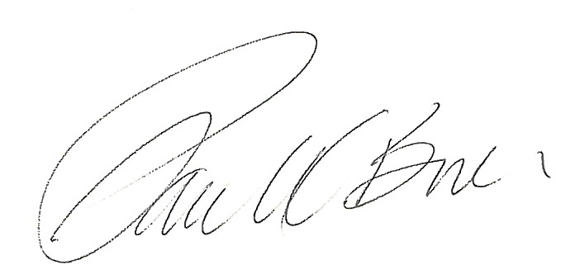
Dr. Paul O’Brien
Chair, CDRAF

Encl:

c.: Dr. Jack Gerrow, CDRAF Executive Director
AMS:807773

