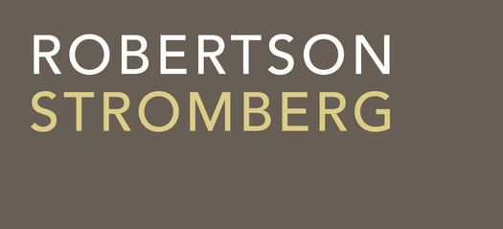March 7, 2023
From: Sean M. Sinclair
Direct: (306) 933-1367
Email: s.sinclair@rslaw.com
File #: 6130
VIA EMAIL: bryan.salte@cps.sk.ca

College of Physicians and Surgeons of Saskatchewan
101 - 2174 Airport Drive
Saskatoon SK
S7L 6M6

Attention: Bryan Salte

Dear Sir:

RE: Dentists injecting neuromodulators

Further to your letter of February 7, 2023 addressed to Dr. Uswak, Registrar of the College of Dental Surgeons (“CDSS”), I confirm that I am legal counsel for CDSS.

CDSS disagrees with the College of Physicians and Surgeons of Saskatchewan (CPSS) that dentists injecting neuromodulators for cosmetic purposes does not fall within section 23(1) of The Dental Disciplines Act (the “DDA”).

Specifically, it is noted that the DDA (section 23(1)(b)) authorizes dentists to perform procedures on tissues in the oral-facial complex below the dermis, below the surface of a mucous membrane or in or below the surfaces of the teeth. An injection of a neuromodulator in the “oral-facial complex” would occur below the dermis and below the surface of a mucous membrane. The injection would be a “a procedure on tissues”. Thus, all of the relevant provisions in the DDA are met and dentists are expressly permitted to perform such procedures.

I understand that CPSS belies that a holistic interpretation of the DDA would demonstrate that, notwithstanding the clear wording of the DDA, it was not intended that dentists be permitted to perform such procedures. In that respect, I can advise:

- Our review of Hansard discussions regarding the DDA do not support the restrictive interpretation being given by CPSS. Specifically, the government indicated that one of the purposes of the new DDA was to allow more flexibility in which professions can perform procedures. The old approach of restricting certain services to only one profession was rejected; and

- The position that, the general purpose of legislation can override the clear text of the legislation is not supported. For instance, in Sullivan on the Construction of Statues, the author notes that clear legislative text will be given deference, particularly when the text is reasonably detailed. Here, we have clear legislative text with a high level of particularization (restricting, for instance, the work of dentists to the “oral-facial complex”). Thus, a generalized position about the general purposes of the DDA would not override the text of the statute itself.

Beyond the legal analysis, I can advise that CDSS is taking a very careful approach to the cosmetic use of neuromodulators. They are requiring members to undertake training before being authorized to perform such procedures. I note that CDSS members will receive as much or more training than many who are currently injecting neuromodulators, including nurses. Thus, from a “protection of the public” standpoint (as opposed to a protection of the profession approach), there is no greater risk in CDSS members performing these procedures than many CPSS members or members of other professions. To the extent that CPSS wishes to obtain any further information about the licencing and training requirements that CDSS is developing, please let me know.

In short, I would suggest that CDSS has the legislative authority to allow members to undertake these procedures and is approaching the matter cautiously from a public protection standpoint.

If you wish to discuss matters further, please let me know.

Sincerely,

Robertson Stromberg LLP
Barristers and Solicitors

Per:

Sean M. Sinclair
SMS Legal Prof. Corp.

SMS:

